**EXPERIMENT – 1**

|  |
| --- |
| Name: Rahul Maurya  UID: 20BCS7260  Class: 807 A |

**AIM:** - Design a Visiting Card containing at least one graphics and text information using Adobe photoshop.

**Hardware Requirements: -** Minimum 384MB RAM, 100 GB hard Disk, processor with 2.1 MHz

**Software Requirements: -** Adobe Photoshop, Photopea

**Tools Used: -** Type Tool, Magic Wand, Lasso select

**Study:**

**Step 1 :-** Create the new project and set the dimensions according to the requirement.

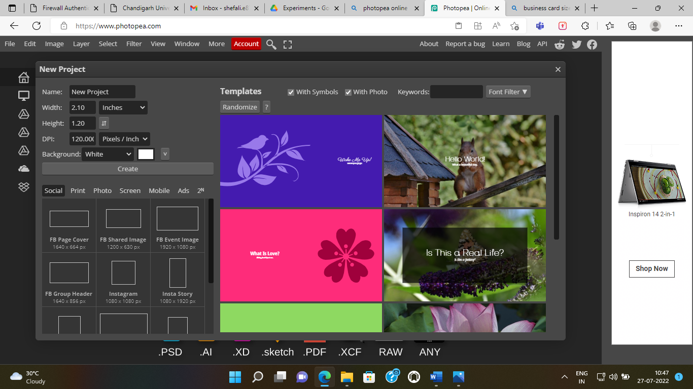



**Step 2: -** Now you have to select the background image for the visiting card. You can take images through various methods.

1. If the image is in your system, then you can take it from FILE ---> Open and place.

2. You can copy the image and paste it on the template.

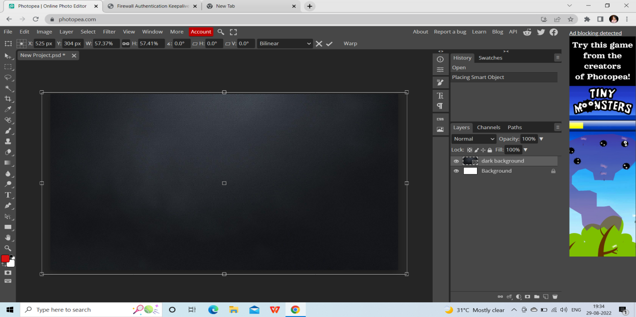

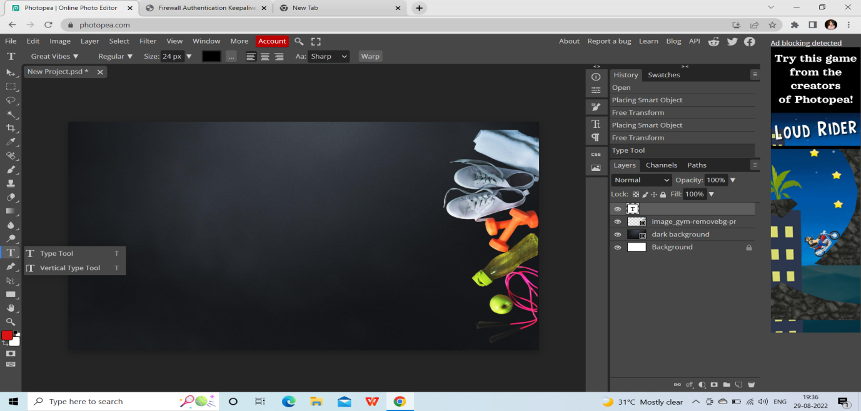

**Step 3: -** After that we need to write down the details of the person or company according to the format of visiting card for that we will use **TYPE TOOL.**

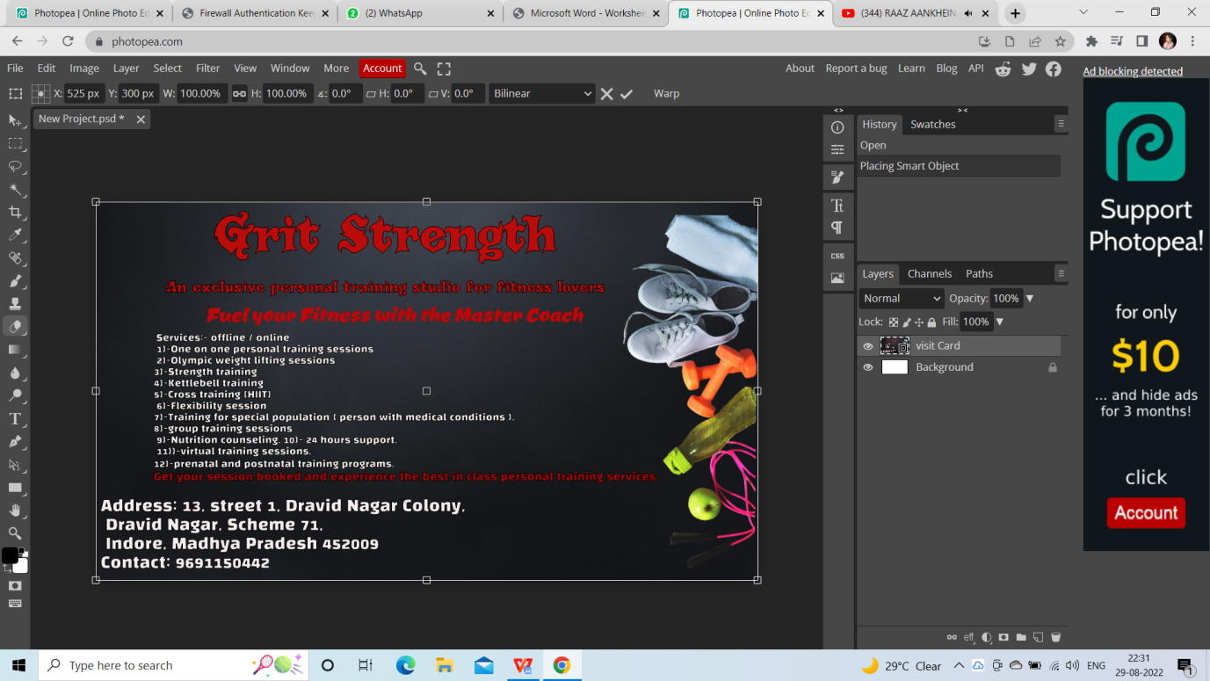

Once you select the type tool the text layer will be added on the above of all the layers.

**Step 4: -** You can also add the image or logo of the organization. For adding the image you can follow step-2.

**OUTPUT :-**

